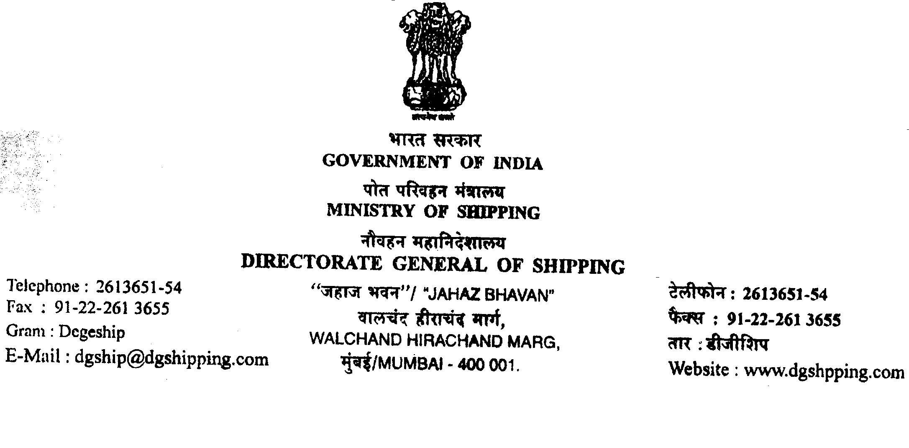
No.14-NT(4)04-PT 30th May 2012
DGS Order No. 04 of 2012
Sub.: Notification on dispensation from the requirements of Shore Based Maintenance Contract (SBMC) for vessels operating exclusively on coast of India.

Whereas Rule No. 17 of Merchant Shipping (Distress and Safety Radio Communication) Rules 1995, which mandates Shore Based Maintenance Contract (SBMC) for all Indian vessels of 300 GT and above plying in Area A3.

Whereas that the whole of coast of India is declared as Area A3 and hence all the vessels on the coast are required to comply with the above requirement.

Whereas facilities are available at most Indian ports which can provide necessary maintenance and repair support for the radio communication equipments within a reasonable time, and all ships operating along the Indian coast can effectively utilize the existing maintenance/repair facilities without much difficulty.

And whereas further that the Coastal Shipping Industry has made several representations to the Directorate for considering dispensation from the mandatory requirements of SBMC for coastal ships.

Having considered the request from the Coastal Shipping Industry and the ready availability of the maintenance/repair facilities on the Indian coast, and recognizing that a provision has already been incorporated in the proposed M.S. (DSRC) Rules 2011, which does not mandate SBMC for ships exclusively operating on the coast of India.

The Director General of Shipping, in exercise of the powers vested in him under the provisions of Section 456 of the M.S Act 1958, read together with S.O. 3144 dated 17.12.1960, hereby exempts Indian ships, other than passenger vessels, exclusively operating along the Indian coast and whose Cargo Ship Radio/Safety Radio Certificate is endorsed to that effect, from the requirements of Rules 17 of M.S. (DSRC) Rule 1995, in respect of Shore Based Maintenance Contract (SBMC).

Sd/-
( Dr. S B Agnihotri)
Director General of shipping
& ex-officio Addl. Secretary to the Govt. of India

