

भारत सरकार / GOVERNMENT OF INDIA
पोत परिवहन मंत्रालय / MINISTRY OF SHIPPING
नौवहन महानिदेशालय / DIRECTORATE GENERAL OF SHIPPING
टेलीफोन: 022-25752040/1/2/3 बिटा बिल्डिंग, 9वीं मंजिल/ Beta Building, 9th floor Tele: 022-25752040/1/2/3
फैक्‍स: 022-25752029/35 आई थिंक टेक्‍नो कैंपस/ I-Think Techno Campus Fax: 022-25752029/35
ई-मेल: dgship-dgs@nic.in कांजूर मार्ग (पूर्व)/Kanjur Marg (East) E-mail : dgship-dgs@nic.in
वेब साइट: www.dgshipping.gov.in मुंबई / MUMBAI-400 042 Web: www.dgshipping.gov.in

No.41-Admn(1)/2016 Dated: 19.05.2016

Subject: - Sealed Quotations invited for deployment of ten personnel for watch and ward duties (without firearms) -– regarding

The Directorate General of Shipping intents to deploy 10 (Ten) personnel for watch and ward duties, one each in three shifts (Total 4), for the security of the Kanjurmarg premises and two each in three shifts (Total 6), for the security of the premises / plot of land wherein the new office building of the Directorate is being constructed, located at Walchand Hirachand Marg, Ballard Estate, Mumbai-400001. The interested agencies may submit the sealed quotations for the said purpose. The terms and conditions for the said purpose are given as under.

The scope of work for providing security services and conditions of contract are elaborated at annexure-I . For the work elaborated in annexure - I, the contractor will deploy ten (10) personnel, including four (4) at Kanjur marg premises. The contractor will have to provide the services strictly as elaborated in annexure-I. The contract shall be terminated at any time, in case, the services are not found satisfactory. The payment will be made on monthly basis only on satisfactory performance of the work.

Instruction to bidders:
1. The bidders may quote consolidated rates for the period of one year. If felt necessary, the interested agencies may inspect the above mentioned premises.
2. The quotation must be submitted in two separate envelopes containing the Technical Bid & the Financial Bid. The Technical bid and the financial bid must be submitted in two separate sealed envelopes, and should be placed in a bigger envelop with the words written on it as: “Quotation for deployment of ten personnel for watch and ward duties (without firearms)” failing which the bid stand disqualify.

3. The technical bid must contain the following:-

- A copy of Provident Fund Registration A/c. No.
(b) A copy of Professional Tax Registration No.
(c) A copy of ESIC Registration No.
(d) A copy of PAN card
(e) A copy of Certificate of Registration under Section 69 of the Finance Act,1994 (32 of 1944)
(f) A copy of Registration Certificate of Establishment under Bombay shops and Establishment Act, 1948.
(g) A copy of License to engage in the Business of Private Security / watch & ward Agency issued by the State / CentralGovernment.
(h) Details of past experience.
(i) A copy of the audited profit and loss account statement along with the Income tax return for the FY 2013-14 and FY 2014-15.
(j) The annual turnover of the bidder in the FY 2013-14 and FY 2014-15 each must be Rs.20 lakhs or more.
(k) A copy of work experience for two or more Central / State Government Organization in last two years. A certificate to that effect should be submitted.
(l) Earnest Money Deposit (EMD) of Rs.20,000/- as a bid security in favour of Directorate General of Shipping, Mumbai in the form of Account Payee Demand Draft, Fixed Deposit Receipt, Banker’s cheque or Bank Guarantee from any of the commercial banks. The bid security will remain valid for a period of 45 days and bid securities of the unsuccessful bidders will be returned on or before the 30th day after the award of the contract. (Format for model Bank Guarantee enclosed)
4. The Financial bid
The Financial bid should be given in a separate envelope and should have the salary structure, as specified by the Ministry of Labour & Employment, GoI from time to time. Provident fund, ESIC contribution, any other statutory payments along with the agency charges and the applicable taxes should be separately indicated. The rate should be quoted for per person per month basis. (At present basic wages plus VDA is Rs 10582/- per month for employment of personnel for watch and ward duties w.e.f April 1, 2016 to September 30, 2016, as specified by the Ministry of Labour & Employment, GoI is at Annexure III) and the bidder should submit a certificate in this regard and as per specimen in Annexure-II (2 pages).

5. The successful bidder will have to submit bank guarantee of 10% of the value of the contract as a performance security deposit in favour of Directorate General of Shipping, which will be refundable after completion of contract. The Performance Security should remain valid for a period of sixty days beyond the date of completion of all contractual obligations of the bidder. The security deposit shall be arranged to be refunded to the contractor after three months on the successful completion of the contract period (including the extended period, if any) and upon the contractor furnishing an undertaking on a non-judicial Stamp Paper of Rs.100/- that the he has settled all statutory dues of persons employed by him. In case of unsettled payments / claims, if any, the contractor will indemnify the DGS against any claim that might be lodged by the persons employed, against the contractor, whether in the Industrial / Labour Tribunal or with the office of the Commissioner of Labour or any appropriate authority. In the event of any breach or violation of the terms and conditions of this contract, the Security Deposit paid by the contractor shall stand forfeited either in part or full at the sole discretion of the Directorate. (Format for model Bank Guarantee enclosed as Annexure IV)
6. The successful bidder will have to enter into an agreement with DGS on a non- judicial stamp paper of Rs.100/-.
7. The successful bidder would submit an undertaking that he will not deploy personnel below 18 years of age.
8. The interested bidders are requested to submit financial bid and technical bid in a separate sealed envelope, failing which the bids will stand disqualified. The bidders may be clearly write “Quotation for deployment of ten personnel for watch and ward duties (without firearms)” on the bigger envelope along with details address and telephone/mobile number. The quotation should reach the undersigned at the Directorate General of Shipping on or before 14.06.2016 by 1300 hrs. The quotation received after date shall not be accepted. The technical bids will be opened first on 14.06.2016 at 1500 hrs in the office of the Directorate General of Shipping, Kanjur Marg, Mumbai. The financial bid of only those firms will be opened which meets the minimum eligibility conditions in technical bids. Once quotation is accepted, no request for change in the rate of contract will be entertained by this office at any circumstances during the period of contract.
9. The interested firms who have submitted quotations may present themselves or through their authorized representative at the time of opening of quotations, if so desired. Over writing must be avoided and if done should be countersigned by the authorized person. The Directorate reserves the right to reject the quotations without assigning any reason. Directorate is not bound to accept the lowest quoted tender. Tenders, with un-commemorative rates with reference to minimum wages are subject to rejection.

Sd/-
(Deependra Singh Bisen)
Asstt. Director General of Shipping

Copy to:-

- As per the list
- Computer cell with a request to upload the tender on DGS website.
- Copy for CPP ( e-tender)

Annexure-I

The terms and conditions of contract :

- The bidder should submit the details of all personnel to be deployed by, on his selection. The details should contain the photograph, name, address, date of birth, Adhar Card number and signature, and with an undertaking by the employer / contractor that the said details have been verified by him with the documents. The personnel would be deployed at the kanjurmarg premises of DG Shipping and the premises of Directorate General of Shipping (DGS), at Walchand Hirachand Marg, Ballard Estate, Mumbai-1, for a period of one year extendable to another one year.
- The qualification of the watch and ward shall be as under;--

a] They should have good health and physique, impressive personality, befitting their work, free from defects of sight, hearing, speech or physical movements with education qualification of VII standard minimum.
b] They should have under gone necessary training from recognized institute in the use of arms or marshal art usually given to military/police security, Ex-infantry security, will be given preference.
c] No watch & ward parsonnel should perform duty under intoxicated condition nor they should consume alcoholic drink inside the premises.
d] They should have good record of character and conduct.
e] The minimum age should be 18 years and maximum age should be 60 years.The watch and ward personnel shall not be permitted to wear any odd wrappers. The dress shall be of uniform color and design. Each watch and ward personnel should have a number and he should wear badge of watch and ward agency with his number. Uniform should consists of a)- pants b)-Shirts c)-Belt d)-Shoes e)-Cap f)-Whistle and lathi / batan g) torches with cells and any other necessary implements for watch and ward personnel. The contractor shall bear all the expenses incurred on these items.
(iii) The following necessary items as per the requirement shall be provided by DGS:
a) Tables b) Chairs c) Telephone d) Alarm system, if found necessary by DGS.

(iv) The personnel for watch and ward duties shall be responsible for protection / safety of persons / property / assets in the premises of DGS and shall exercise control on entry / exit of visitors. The security of the assets and properties located in various offices /Installations /Buildings/ Stores etc. shall be ensured. Contractor shall help in establishment of congenial and friendly atmosphere in the premises. Any person found in alcoholic condition, abusing, threatening, engaged in an unauthorized demonstration shall be checked and brought to the notice of DGS. Also any person found to be damaging any property, or suspect of any tress-pass or theft, or moving with any mal-intention should be checked and brought to the notice of DGS. This equally applies to any employee of DGS as well as any outsider found in the premises. Any person found to be damaging assets inside or around premises shall be checked and brought to the notice of DGS. Employee / visitor found in alcoholic condition shall not be allowed to enter inside the building/ stores, etc. even for performing duty. Anti social elements, criminals or history sheeters shall not be allowed inside the premises. Any person of doubtful character or declared not bonafide by DGS shall not be allowed to enter inside the premises. No undesirable and ant-social activities shall be allowed within the premises and the areas adjoining the campus upto the public road around the premises. No unauthorized construction / activity in the premises or in the areas adjuring the premises upto the public road shall be allowed. All help shall be extended to any bonafide inmates of the premises who are in need of help by the watch and ward personnel on duty. The necessary records for the purpose of security shall be maintained at various entrance gates as per the procedure laid down by DGS. No cattle / unauthorized animal shall be allowed to enter inside the Premises. All the main gates of the premises should normally be kept closed. Any suspected entry should be allowed only after due verification.
(v) Functions and duties of watch and ward:--In order to provide security as per clause (iv) above, the duties and functions of watch and ward shall be as under--

(1) While on duty ,watch & ward personnel shall always remain alert throughout the duty period and standing at the gates located.

(2) Watch and ward personnel shall man the entry point of premises or any other building /stores/ installations specified by DGS

(3) Watch and ward personnel shall check and maintain the record of any major items like fridge, TV, Cooler, VCR, A/C, Furniture, Office equipments, etc. being taken in or taken out of premises.

(4) Watch and ward personnel shall patrol entire premises during entire duty time. The patrolling should also be resorted to along the boundary wall wherever possible to check unauthorized entry / exist of men and material and at any other points specified by DGS.

(5) Watch and ward personnel will also follow any other methods / instructions /prescribed / issued by DGS with regard to security.

(6) Watch & ward personnel shall protect departmental employees and Material.

(vi) The personnel for watch and ward duties should be present on all days. In the absence of any personnel, a suitable replacement should be provided by the agency immediately. The absence and the replacement must to be intimated to DG Shipping immediately. In case absenteeism or any other reason what so ever the contractor should replace the watch and ward personnel within half an hour to one hour.
(vii) The personnel for watch and ward duties would be deployed for twenty four hours on rotational basis, every day and the contract shall be for one year from the award of the contract.
(viii) The mode of payment would be on monthly basis through e-payment or Government cheque, only on satisfactory performance of the work. No interest would be payable on delay in the payment.
(ix) The department also reserves the right to alter and or add any terms and conditions as necessary and as per the policy of the department during the currency of the contract.
(x) The contract will be terminated at any point of time without assigning any reason. This Directorate reserves the right to modify/amend or delete any of the terms and conditions. The contractor is personally responsible for theft / loss of departmental property due to negligence of watch and ward on duty employed by the contractor. In case it is noticed by DGS that the work entrusted to be carried out by the contractor is not upto the required standards, 7 days notice in writing shall be given to him, drawing his attention for the bad status and sub standard work and asking him to improve upon the standard. In the event of the authority finding that , there is no improvement thereafter and the work entrusted to him not being carried out as per instructions and specifications, the contract shall be liable to be terminated by giving him short notice. The decision of the authority in this behalf shall be final.
(xi) The successful bidder / contractor would be responsible for deduction and deposit of all the statutory dues of the personnel deployed such as Provident fund, ESIC etc along with its own contribution. All the statutory obligations should be complied with by the successful bidder / contractor and should ensure timely payment of the salaries to the personnel deployed and failure to do so may result in termination of contract.
(xi)

(xii) Penalty Clause: In case of non-compliance of the terms and conditions of contract, a penalty may be levied by DGS. The penalty for some of the defaults is as under. Any delay in attending to the duties without any justifiable cause would lead to deduction of proportionate service charges. In case no replacement is provided, an amount per day per person on prorata basis will be deducted from the bill. Any expenditure incurred by DGS to face the situation arising out of the default or negligence of work of watch and ward should be made good by the contractor.

Sr. No | Name of Default | Penalty Rs.
01 | Late Reporting | 75% of proportionate contract charges per day
02 | Non-reporting | 150% of proportionate contract charges per day
03 | Refusal of duties | 100% of proportionate contract charges per day
04 | Change of personnel without permissions | Rs.200/- per instance
05 | Non observation of dress code | Rs. 100/- per instance
06 | Misbehavior with staff members | Rs. 5000/-

****

Annexure-II (Page 1)
Date :______________
PRICE SCHEDULE /BID

Sr.No. | Category | Cost per month per person | Total manpower required | Total cost per month | Total cost per annum
1. | The personnel for watch and ward duties |  | 10
Total
Service tax
Grant total

This is to certify that the above wages are in compliance with the minimum wages prescribed by the Ministry of Labour & Employment, GoI from time to time.

________________
[Name, Signature and seal of the proprietor ]

Annexure-II(page 2)

Elements of Pay | Name of Category  The personnel for watch and ward duties
BASIC WAGES
VDA
Other allowances
TOTAL BASIC +VDA + ALLOWANCES (A)
DEDUCTIONS
PROVIDENT FUND- @ 12% on Basic +DA
ESIC @ 1.75%
Any other deduction[s]
Professional Tax
TOTAL DEDUCTIONS (B)
TAKE HOME PAY (A-B)
CONTRIBUTIONS OF EMPLOYERS
PROVIDENT FUND @ 13.61% on Basic + DA
ESIC @ 4.75% (on total salary except washing)
Bonus
Any other contribution[s]
TOTAL CONTRIBUTION ( C )
TOTAL (A+C)
Service Charge
Total
Applicable Service Tax
Grand Total

________________

[Name, Signature and seal of the proprietor]

Annexure-III

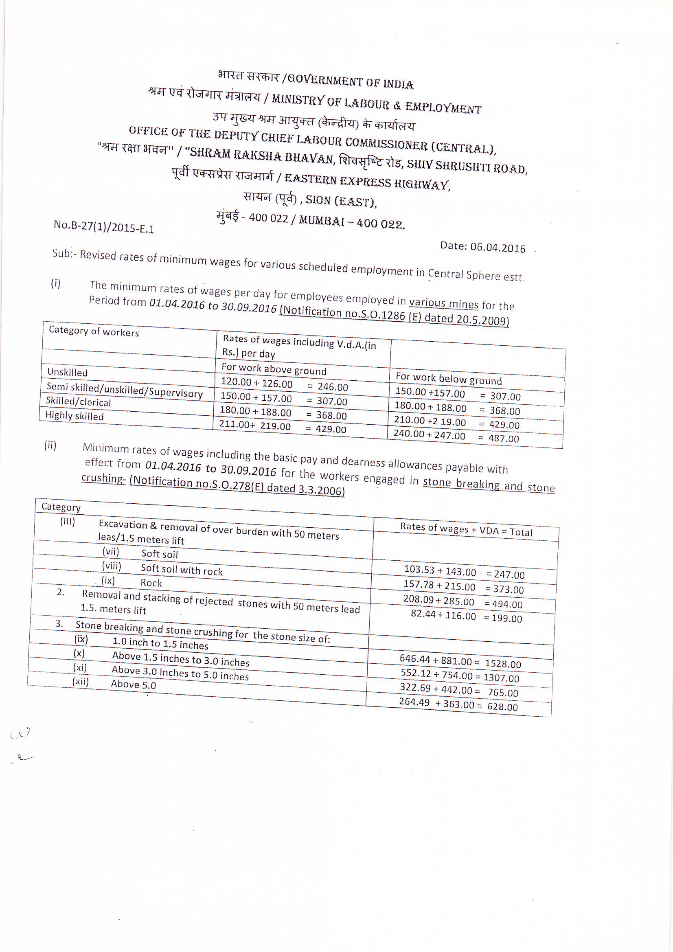
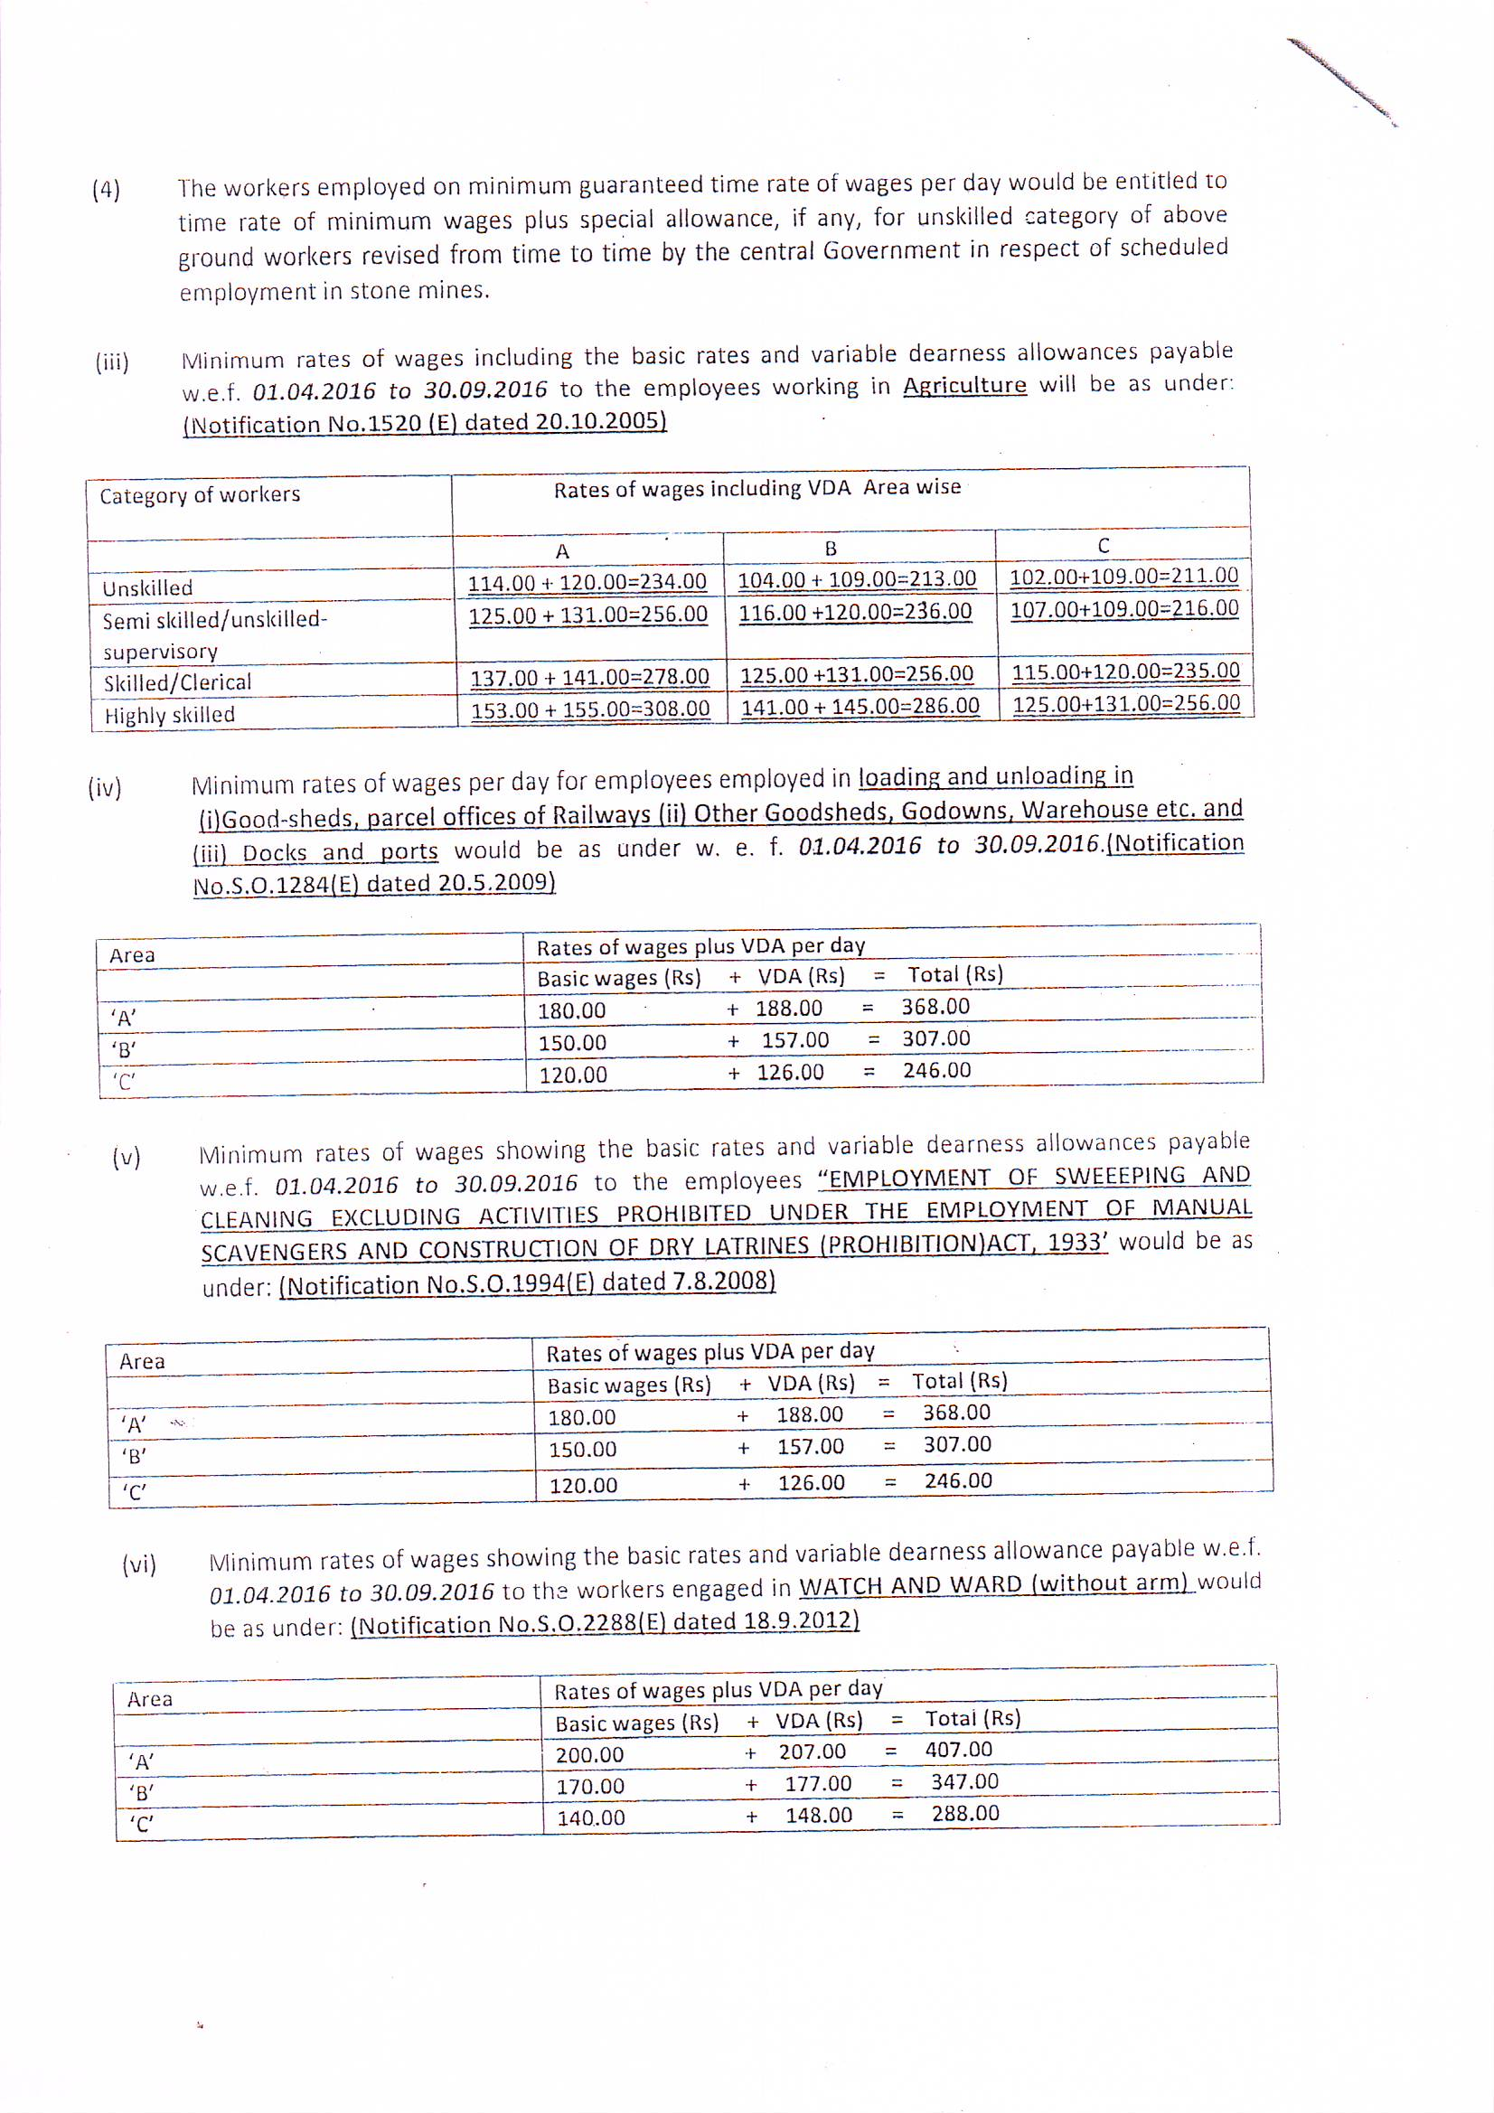
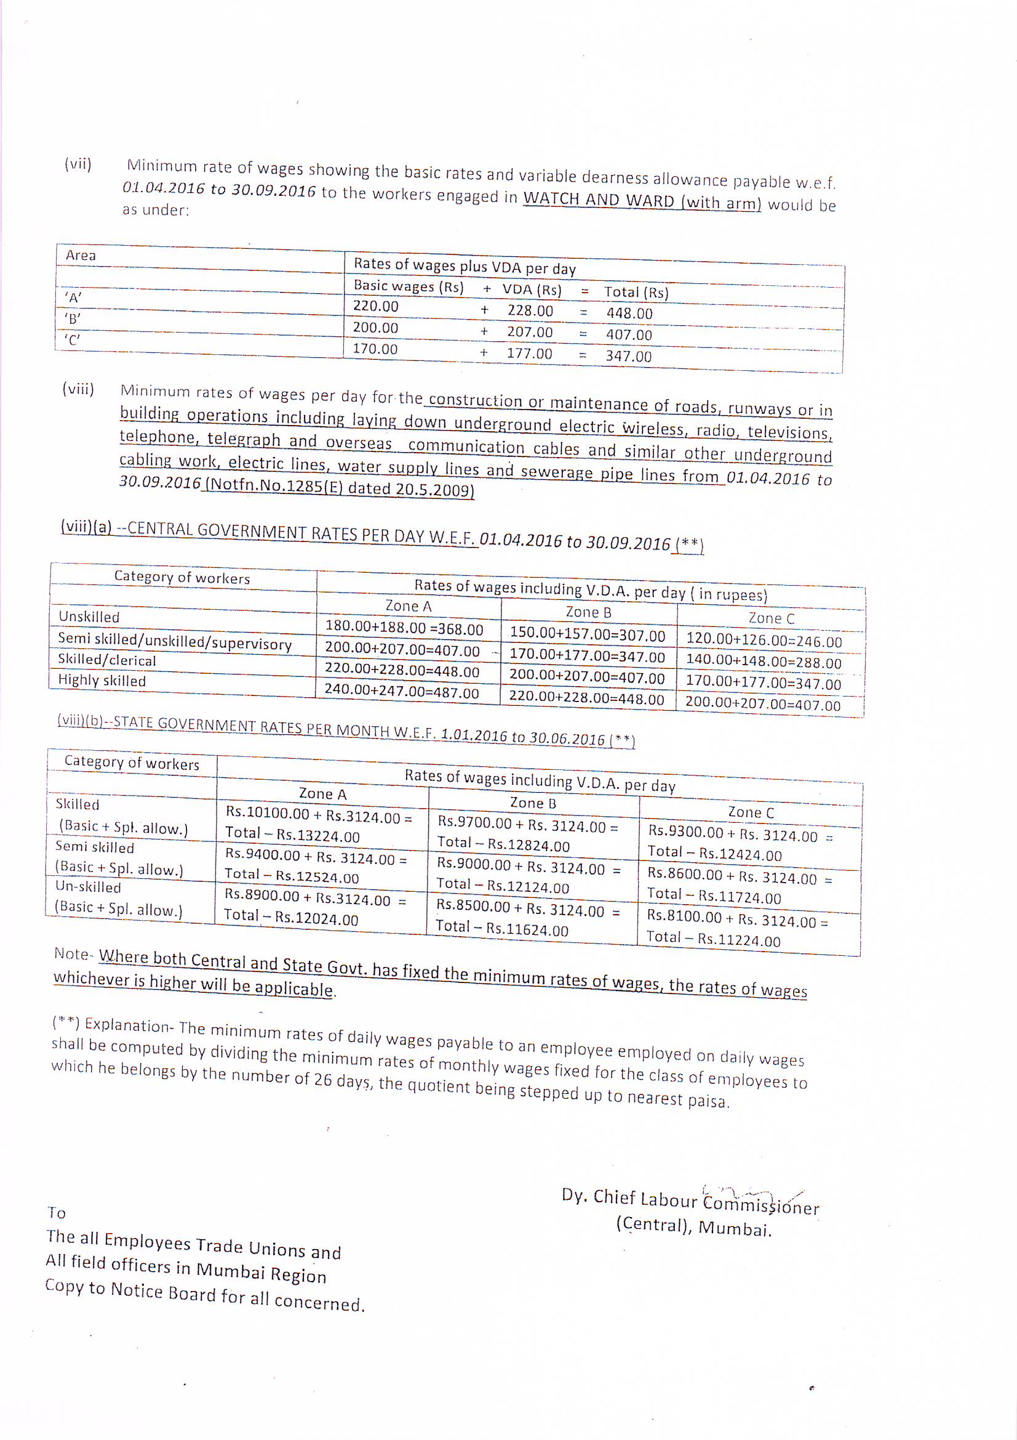

Annexure IV
